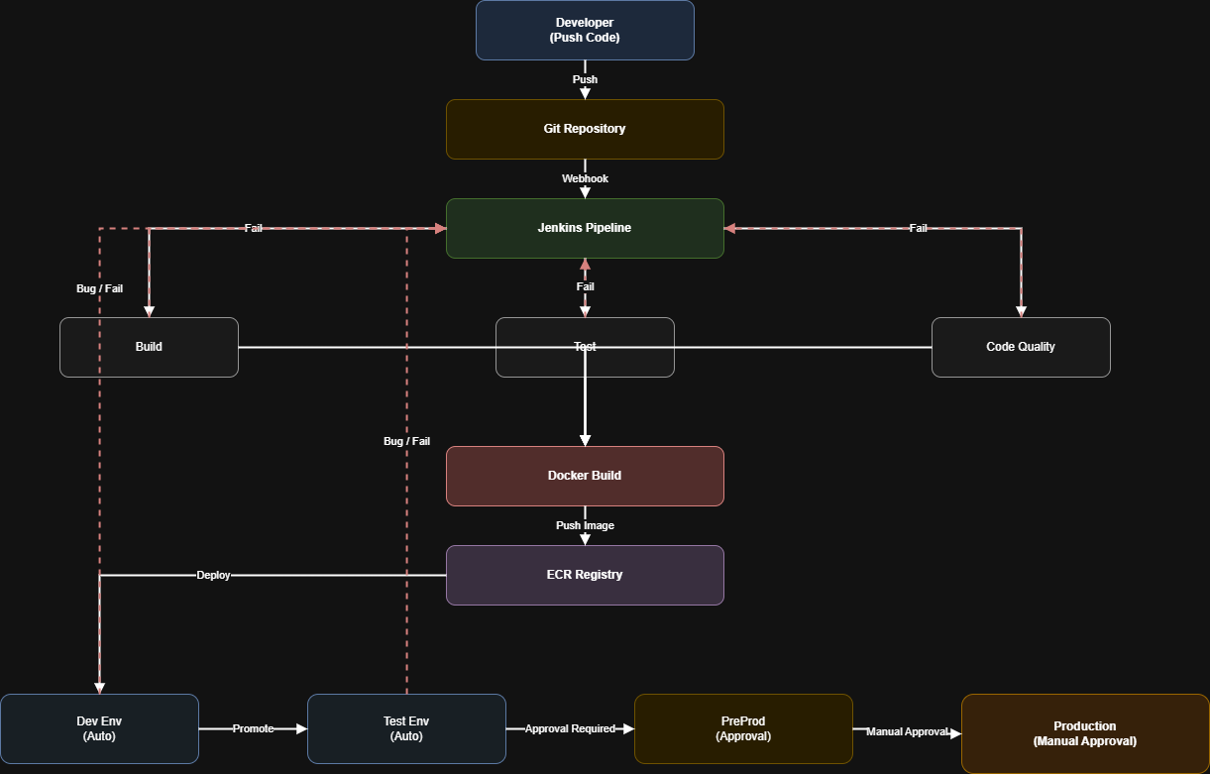

The CI/CD pipeline starts when a developer pushes code to a Git repository, which triggers a webhook to initiate the Jenkins pipeline. Jenkins orchestrates the continuous integration process by running parallel stages including build, test, and code quality analysis (such as unit tests and static analysis). If any of these stages fail, the pipeline stops and provides immediate feedback to the developer for fixes. Once all stages pass successfully, Jenkins proceeds to build a Docker image of the application and pushes it to a container registry like Amazon ECR. From there, the continuous deployment flow begins, where the application is automatically deployed to the Dev environment for initial validation. If successful, it is promoted to the Test environment for further testing. After passing test validations, the deployment moves to Pre-Production, which requires approval before proceeding. Finally, with manual approval, the application is deployed to Production. At any stage, if issues or bugs are detected in Dev or Test environments, feedback loops send the process back to Jenkins, ensuring continuous improvement and reliable delivery.

The Continuous Deployment (CD) phase begins after a successful build and Docker image is pushed to the registry (such as Amazon ECR). The pipeline then automatically pulls the latest image and deploys it to the Dev environment, where basic smoke testing and initial validation are performed. If the application behaves as expected, it is promoted to the Test environment, where more comprehensive testing such as integration and regression testing takes place. Once validated, the deployment moves to the Pre-Production environment, which closely mirrors production and typically requires stakeholder or QA approval before proceeding. After approval, the application is finally deployed to the Production environment through a controlled release process, often involving manual approval to ensure stability and risk mitigation. Throughout the CD pipeline, deployment strategies like rolling updates or blue-green deployments can be used to minimize downtime. If any issues are detected in Dev or Test stages, feedback loops trigger a rollback or redeployment process, sending control back to the pipeline to fix and redeploy, ensuring a reliable and continuous delivery cycle.

Complete CI/CD flow in steps
1. Developer writes code
The developer implements a feature, bug fix, or enhancement in the application code.
2. Code is pushed to Git repository
The developer pushes the code to a branch in GitHub, GitLab, or Bitbucket.
3. Webhook triggers Jenkins pipeline
As soon as code is pushed, a webhook automatically triggers the Jenkins pipeline.
4. Jenkins starts CI process
Jenkins checks out the latest code from the repository and starts the CI stages.
5. Build stage runs
The application is compiled or packaged.
Examples:
- Java → Maven / Gradle build
- Node.js → npm build
- Python → package validation / dependency install
6. Test stage runs
Jenkins executes test cases such as:
- unit tests
- integration tests
- API tests
If tests fail, pipeline stops and feedback goes back to developer.
7. Code quality check runs
Static code analysis tools like SonarQube check:
- code smell
- bugs
- vulnerabilities
- coverage
- maintainability
If quality gate fails, pipeline stops.
8. Docker image is built
If build, test, and quality stages pass, Jenkins creates a Docker image for the application.
9. Docker image is tagged
The image is tagged with build number, version, or commit ID.
Example:
myapp:25
10. Docker image is pushed to registry
The image is pushed to a container registry like:
- AWS ECR
- Docker Hub
- Nexus
- Artifactory
This completes the CI part.

CD part starts here
11. Jenkins connects to Kubernetes cluster
After the image is available in the registry, Jenkins connects to the target Kubernetes cluster.
12. Namespace is created or verified
Jenkins applies namespace.yaml to create the environment namespace such as:
- dev
- qa
- preprod
- prod
Example:
kubectl apply -f namespace.yaml
13. Deployment YAML is applied
Jenkins applies deployment.yaml, which creates pods using the latest Docker image from ECR.
This file defines:
- image name
- replica count
- container port
- labels
- rollout strategy
Example:
kubectl apply -f deployment.yaml
14. Service YAML is applied
Jenkins applies service.yaml to expose the deployment internally inside the cluster.
The Service provides a stable internal endpoint for the pods.
Example:
kubectl apply -f service.yaml
15. Ingress YAML is applied
Jenkins applies ingress.yaml to expose the application externally using host/path-based routing.
Traffic flow becomes:
User → Ingress → Service → Pods
Example:
kubectl apply -f ingress.yaml
16. Rollout verification happens
Jenkins verifies whether deployment is successful.
Example:
kubectl rollout status deployment/myapp -n dev
kubectl get pods -n dev
kubectl get svc -n dev
kubectl get ingress -n dev
17. Application is deployed to Dev environment automatically
The latest version is first deployed to Dev for smoke testing and initial validation.
18. Promote to Test environment
If Dev is stable, the same process is repeated for Test/QA environment.
19. Move to PreProd with approval
After successful testing, deployment is promoted to PreProd.
Usually QA or release approval is required here.
20. Deploy to Production with manual approval
Once PreProd validation is complete, a manual approval is given and Jenkins deploys to Production.
21. Production is exposed to end users
Ingress routes external traffic to the production service, and the app becomes live.
22. Failure handling and feedback loop
If any issue happens in:
- build
- test
- code quality
- dev deployment
- qa deployment
the pipeline stops or rolls back, and feedback is sent back for fixing.

🔁 How code moves from Dev → Test → PreProd → Prod

✅ APPROACH 1 (Most Common): Same Image Promotion (Best Practice)
👉 Important concept:
We do NOT rebuild code again.
We promote the SAME Docker image across environments.

4. Promote to Test (QA)
- Pipeline promotes image:
myapp:25 → Test
- Either:
  - automatic promotion
  - or approval-based trigger
👉 Deployment happens using same YAML/Helm with different config
✅ Test environment:
- Integration testing
- Regression testing
- End-to-end testing

5. Create Release Branch (Optional but common)
Once QA is stable:
release/v1.0
👉 Used for:
- stabilization
- bug fixes only (no new features)

6. Deploy to PreProd (Staging)
- Requires approval (QA/Product/Manager)
- Same image promoted:
myapp:25 → PreProd
✅ PreProd:
- Production-like environment
- Performance testing
- UAT (User Acceptance Testing)

7. Merge to main (Production readiness)
👉 ONLY after PreProd success:
release/v1.0 → main
This is a controlled merge:
- Code is frozen
- Fully tested
- Approved

8. Deploy to Production
- Manual approval (very important)
- Pipeline deploys same image:
myapp:25 → Production
Using:
- Kubernetes YAML / Helm
- Rolling update / Blue-Green / Canary

